**September 2024**



CCMVNET

We hope you are all well and have enjoyed your summer. We would like to inform you about recent activities and update you on our latest achievements.

The Congenital CMV Network (cCMVnet) is a European initiative promoting international collaboration, research and educational activities for cCMV. In 2020 the Network established the European cCMVNET registry collecting data on epidemiology, clinical characteristics, long term sequelae, and treatment of infants born with cCMV.

With our newsletter we want to update you on our projects on a regular basis and give you an insight into where we are active, which new ideas we are implementing and where we would welcome your support.

**CCMVNET REGISTRY DATA**

Currently, cCMVnet has **159 member**s working in different European Hospitals and Research Centres from **36 countries**. Most of our network members are from: UK (46), Spain (22), and Greece (14). Every month, we expand this list, adding new professionals and countries to the CCMVNET community. We would like to spread the information of our registry even more, that we can enroll as much children as we can, so please don´t hesitate and spread the information to others to join us!

**CCMVNET European Registry – now has more than *1500 children* enrolled – thanks to all the families and clinicians!**

Currently, the global cCMVnet database has more than 1500 patients, the database has **grown by more than a third over the past 10 months.** Most of the patients come from Spain (901), Italy (209), Greece (180), UK (62), and Switzerland (48). The network is working on expanding the database with new hospitals located in Italy, Belgium, Bulgaria, Germany, Ireland and Netherlands. Do not hesitate to contact us if you wish to join and start enrolling your patients.

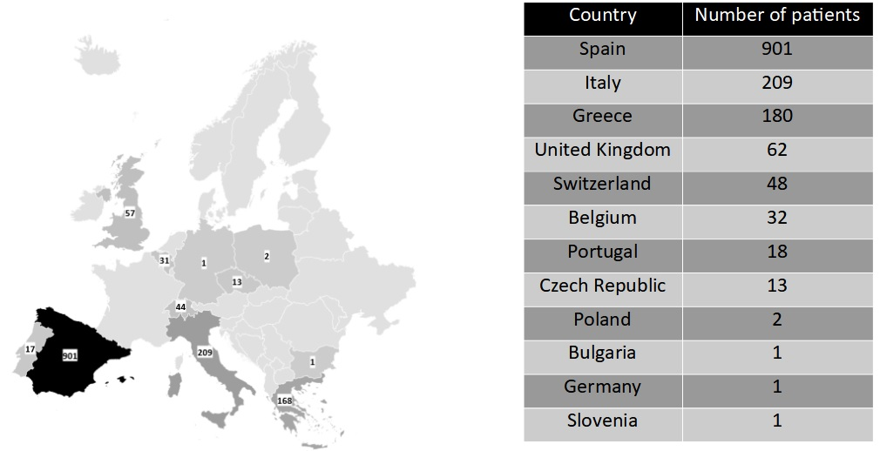

***Number of CCMVNET members per-country***

|  |  |
| --- | --- |
| ***UK*** | ***46*** |
| ***Spain*** | ***22*** |
| ***Greece*** | ***14*** |
| ***Italy*** | ***13*** |
| ***Switzerland*** | ***12*** |
| ***Germany*** | ***9*** |
| ***Netherlands*** | ***5*** |
| ***Portugal*** | ***3*** |
| ***Israel*** | ***3*** |
| ***Slovenia*** | ***3*** |
| ***Belgium*** | ***2*** |
| ***Poland*** | ***2*** |
| ***Norway*** | ***1*** |
| ***USA*** | ***1*** |
| ***Czech republic*** | ***1*** |

**RESEARCH ACTIVITIES AND PUBLICATIONS**

As a great success we consider publication of a new [**Consensus recommendation for prenatal, neonatal and postnatal management of congenital cytomegalovirus infection from the European congenital infection initiative (ECCI)**](https://www.thelancet.com/journals/lanepe/article/PIIS2666-7762(24)00058-9/fulltext) published in April 2024. A cCMV guidelines group was convened under the patronage of the European Society of Clinical Virology in April 2023 to refine insights regarding maternal primary infections. The group consisted of experts from all fields such as paediatric infectious diseases, neonatology, gynaecology, virology/microbiology. The resulting recommendations address managing cCMV, spanning prevention, diagnosis, treatment to postnatal care. It shows how early and accurate maternal diagnosis through serological tests enhances risk management and prevention strategies, including using valaciclovir to prevent vertical transmission. The guidelines also strive to refine personalized postnatal care based on risk assessments and ensuring targeted interventions for affected families.

Other published papers, or those submitted for publication, are listed below. Because one of our objectives is to highlight important work including that by our CCMVNET colleagues - if anyone would like to be featured with publication in the next issue, please let us know by email.

Published papers:

* **Gkentzi D**, Blázquez-Gamero D, Buxmann H, Drysdale SB, Papaevangelou V, Lyall H. **Congenital CMV Monthly International Virtual Clinics: A cCMVnet European Initiative.** Pediatr Infect Dis J. 2024 Jan 1;43(1):e26-e27. doi: 10.1097/INF.0000000000004133. Epub 2023 Oct 20. PMID: 37922475.
* **Petrunin, Yury MBChB, BSc**\*; Payne, Helen MBChB, PhD†; Blázquez-Gamero, Daniel MD, PhD‡; Buxmann, Horst MD, PhD§; Drysdale, Simon B. FRCPCP, PhD¶; Gkentzi, Despoina MD, PhD‖; Papaevangelou, Vana MD, PhD**; Lyall, Hermione MD†. **Discrepancies in Management of Congenital Cytomegalovirus in Preterm Infants: An International Survey.** The Pediatric Infectious Disease Journal ():10.1097/INF.0000000000003995, June 08, 2023. | DOI: 10.1097/INF.0000000000003995

Submitted for publication:

* **Papaevangelou V et al.** Severe neutropenia in infants with congenital cytomegalovirus infection treated with (val)-ganciclovir.
* **Villaverde S et al.** Antiviral treatment and risk of hearing loss in asymptomatic and mild symptomatic infants with congenital Cytomegalovirus.

Ongoing research activities:

* Development of a risk SCORE for long-term sequelae.
* Description of late-onset hearing loss and associated risk factors.
* Description of neurodevelopmental impairment in cCMV and associated risk factors.
* Description of the prevalence of autism spectrum disorder (ASD) in cCMV patients versus controls.

# **For all recruiting members: welcome to submit proposals!**

# **WEBSITE**

Our [website](https://ccmvnet.org/) is being regularly updated, you can find there actual information about cCMVnet registry, all current ongoing studies, information about actual Steering committee members. In the section dedicated to education you can find planned educational activities with dates of both Virtual clinics and Webinars and also a **recording of the last webinar** dedicated to the new cCMV guidelines.

**EDUCATION**

We continue the tradition of organizing **cCMVNET virtual clinics**, an online forum for clinicians to review complex cases and treatment strategies in cCMV. Virtual clinics are taking place every last Wednesday of each calendar month, at 17.00 CET, except for summer and Christmas holidays and the month when ESPID meeting is held.

Since February 2021 we have run **24 Virtual clinics**, with over **84 cases**. Approximately **40 clinicians across multiple specialties** (general paediatrics, neonatology, paediatric infectious diseases, audiology, obstetrics, ENT, virology) and countries (including Spain, UK, Greece, Germany, Estonia, Iceland, Denmark, Israel, Czech Republic, Armenia, Malaysia, India and many more) attended each clinic. Topics which have been discussed were mainly: treatment options, side effects, cCMV in preterm babies, diversity of clinical symptoms such as hearing impairment, neurological findings and MRI considerations, hepatic impairment, platelet count changes, cCMV treatment in pregnancy, and difficulties with diagnosing of cCMV. Recommendations from the cCMVnet steering committee and other experts were provided. Everyone presenting a case will afterwards obtain **Certificate of presentation at the cCMV Virtual clinic**.

**Anyone interested in presenting a case, or who would like to simply attend for educational purposes is more than welcomed - contact** [**ccmvnet@gmail.com**](mailto:ccmvnet@gmail.com)**.**

We also organise regular **webinars** on the latest updates in cCMV, which are free to attend. So far, 5 CCMVNET webinars were held on topics of blood expression profiles in infants with cCMV, asymptomatic infant with cCMV, pregnancy, prevention and cCMV, cCMV infection and hearing loss, brain imaging and brain pathophysiological effects of cCMV, and new European guidelines for cCMV. Record of the latest webinar regarding newly published **Consensus recommendation for prenatal, neonatal and postnatal management of congenital cytomegalovirus infection** is available online on our website [here](https://drive.google.com/file/d/1ilAH4Pu8Ldotm6YpZy0mCFmroNJfeNBN/view).

**SAVE THE DATE**

|  |
| --- |
| cCMV WEBINAR IN 2024 |
| Next webinar CMV infection and prematurity will be held **on 13.11.24 (17:30 - 18:30 CET)** and will focus on postnatal CMV infection. Anyone interested, please contact [ccmvnet@gmail.com](mailto:ccmvnet@gmail.com). Agenda:  5.30-5.45pm  *Epidemiology and clinical presentation of symptomatic postnatal CMV-infections in preterm infants,* Horst Buxmann    5.45-6.00pm  *Ganciclovir / valganciclovir use in preterm infants: a single center experience*, Asrar Abu Bakar    6.00-6.15  *Developing a novel (val)ganciclovir dosing strategy for preterm infants through pharmacokinetic research,* Tom Jacobs |
|  |
|  |

## **ANNUAL GENERAL MEETING 2024**

Please save the date for our second AGM, which will be held **on 4.12.24 (17:00 – 18:00 CET),** and you are all welcome to join. We will send you agenda and a link for the meeting soon, and we look forward to meeting up.

|  |
| --- |
| cCMV VIRTUAL CLINICS IN 2024 (17:00 - 18:00 CET) |
|  |
| * 25th September * 30th October |
| * 27th November |

# **PAST MEETINGS 2023/2024**

**CCMVNET at ESPID 2024 Copenhagen**

During spring 2024 **Annual Pediatric Infectious Diseases Meeting** took place in Copenhagen. We were glad to be able to present our work at the largest congress of PID as part of the Research lunch session.

* **Research lunch session**

Chair Vana Papaevangelou presented our latest data from the registry and update on CCMVNET activities, emphasizing new European guideline for management of CMV. Simon Drysdale showed our research activities, Despoina Gkentzi presented our educational activities and Young ESPID members, together with colleagues from UK, Slovenia and Greece, presented 3 interesting case reports, which were also part of our regular Virtual clinics in past. After each of the case there was an interactive session with voting. The session was followed by fruitful discussion of hot topics in cCMV – treatment after 3 weeks of age, screening and diagnostics.

* **Parallel symposium: Congenital infections**

On the last day of the conference Chair of the cCMVnet Vana Papaevangelou was moderating the parallel symposium on congenital infections. The focus was put on pros and cons of cCMV screening and on treatment of pregnant women with CMV.

# **UPCOMING EVENTS**

We are all looking forward to the **European Congenital Cytomegalovirus Initiative to be held in Leiden, Netherlands, 9. - 11. October 2024** that some of our steering committee members will attend in person and present our actual research activities.

**Looking forward meeting you there!!**

**CHANGES IN THE STEERING COMMITTEE 2024**

After the extension of the period in office due to COVID 19 pandemic, turnover of the functions was planned for the beginning of 2024. Our small, but devoted, cCMVNET team has welcomed 2 members.

Starting in 2024 the founding member of the cCMVnet and to date chair Hermione Lyall stepped down from her function and Vana Papaevangelou, former secretary of cCMVnet, was elected as the new chair. We also welcomed newly elected Arnaud L’ Huillier as a cCMVnet secretary.

Rest of our small, but devoted team, remains the same.

Let us introduce you our old – new members:

**Vana Papaevangelou – Chair**

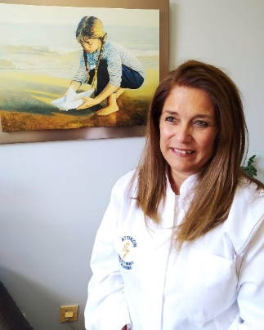

Professor Vana Papaevangelou is a trained paediatrician, with a special interest in paediatric infectious diseases. After completing her paediatric residency and PID fellowship at the NYU Medical Centre, USA, she returned to Athens Greece and has been a full-time clinical paediatrician in tertiary teaching hospitals since 1996. Professor Papaevangelou has been actively involved in the education of medical students and paediatric residents. Since September 2013 she has been appointed Chairman of the Third department of Pediatrics of her University which is located at ATTIKON hospital, a tertiary University Hospital. Over the past 25 years, Professor Papaevangelou has been actively involved in multiple research projects. Her main interests involve the epidemiology of vaccine-preventable diseases and vertical transmission of infections especially cCMV. She is one of founding members of the cCMVnet, a scientific committee working on congenital CMV. She is a member of the National committee for COVID-19 response, the National Advisory Board for Immunization Practices, the scientific committee of the Greek CDC, the National Hepatitis Board and the Viral Hepatitis Prevention Board. She is a Board member of ESPID since May 2019. Prof V Papaevangelou has published more than 170 papers in peer reviewed journals, with an H-Index: 35 and more than 3800 citations.

**Arnaud L’ Huillier – Secretary**

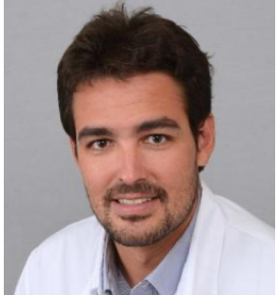

After completing his Medical School and Pediatrics residency at the University Hospitals of Geneva and Faculty of Medicine, Switzerland, Dr L’Huillier’s interest in infectious diseases and clinical virology motivated a 2-years fellowship in Pediatric Infectious Diseases at the Hospital for Sick Children, Toronto (Canada). He then completed another 2-years research fellowship in Transplant Infectious Diseases at the University Health Network in Toronto, focusing on transplant virology. In 2019, he has been appointed as a Junior Faculty in Geneva University Hospitals’ Pediatric Infectious Diseases Unit where he continues to focus on clinical care and research projects in pediatric infectious diseases. During the COVID-19 pandemic, he was selected to represent the Swiss Society of Pediatrics within the Swiss National COVID-19 Science Task Force. Since 2022, he is the head of the Pediatric Infectious Diseases Unit of Geneva University Hospitals and as of 2024, he also leads the clinical trial unit of the Pediatric, Gynecology and Obstetrics department. His primary research interest is congenital CMV and post-transplant CMV.

# **Do Join Us!**

**Building up a strong cCMV community as well as the European registry is one of our goals. Therefore, we encourage everyone to become a member of the cCMVnet initiative, take part in as many cCMV activities as you can, and take advantage of registering your patients into our database.**

IF YOU ARE INTERESTED IN ANY ACTIVITIES MENTIONED, PLEASE,

CONTACT [CCMVNET@GMAIL.COM](mailto:CCMVNET@GMAIL.COM)